

**Shift-X-Wire**

Orscheln Products L.L.C. has released a new Shift-X-Wire™ system. The Shift-X-Wire™ 4.2 is comprised of a push button shift selector, PBSS, and an electronic actuator, which rotates the selector shaft on Allison Transmission® 1000 & 2000 series transmissions.

The Shift-X-Wire™ 4.2 system replaces the mechanical shift lever and control cable that is standard in medium duty trucks and buses with the Allison Transmission® 1000 & 2000 series.

Gear and park pawl selections are made from the PBSS and are communicated over CAN via SAE J1939 to the Allison Transmission® controller. The actuator listens to this communication and moves the selector shaft to the requested position. The shift selector displays the requested and current gear as reported by the transmission controller.

The PBSS can also request and display SAE J2012 Diagnostic Trouble Codes from the Allison Transmission® controller.



PBSS

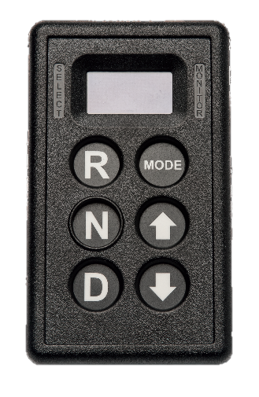

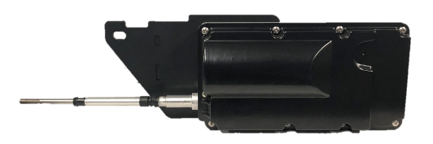

Actuator

The Orscheln Shift-X-Wire™ 4.2 system can simplify vehicle dash design. The PBSS has the same footprint as the Allison Transmission® shift selector in larger series transmissions . It is also applicable for rear engine vehicles, and anywhere a smart shift system can benefit the user. The 4.2 system can be specified on many OEM chassis and is available from Orscheln select distributors.

Allison Transmission® is a registered trademark of Allison Transmission® Inc.

[www.orschelnproducts.com](http://www.orschelnproducts.com)

10/2018