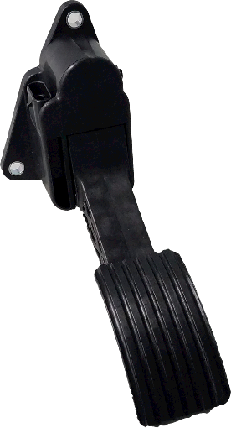
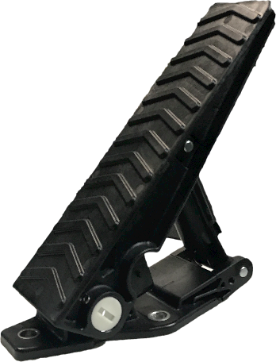
ELECTRONIC THROTTLE CONTROLS

PRODUCT BENEFITS

Smooth responsive interface Mech. kick down available
Dual programmable outputs 100% end-of-line testing
Analog or PWM Signal Tested to SAEJ1455

SPECIFICATIONS
Global II Suspended Pedal
EC0200-XXX-XXX
Gen II Floor Mount
EC0500-XXX-XXX

GENERAL SPECIFICATIONS
Material  Weight | PA 66 33% GF  0.350 kg (0.772 lbs)
Environmental Conditions  - Storage Temperature  - Operating Temperature  - Humidity | -55˚C to 105˚C  -40˚C to 105˚C  96 % RH for 240 hours -40˚C to 85˚C
MECHANICAL SPECIFICATIONS
Travel  Operating Loads  Durability | 20˚±1˚ Angular Travel  Idle 3.3Nm±1Nm, WOT 6.8Nm±1.4Nm  4.8 Million Loaded Endurance Cycles (min.)
Overload  Random Broadband Vibration  Swept Sine Vibration | 1800N  8 Hours, 3 Axis 7.68 Grms  Displacement 1.5mm from 10Hz to 57Hz, Acceleration 69.3m/s² RMS (10g peak) from 57.5Hz to 2000Hz
ELECTRICAL SPECIFICATIONS AND STANDARDS CONFORMITY
Power Supply | 5VDC
EMI/EMC | ISO 13766, EN13309, ISO 14982 and UN ECE Reg. 10.05
Fording & Ingress Protection | Meet IEC 60529 – IP67, IPX9K
Restricted Substance | IMDS, GADSL & RoHs Compliant
www.orschelnproducts.com 9/11/18

